

***(An Autonomous Institute)***

**Walchand College of Engineering, Sangli**

Department of Computer Science & Engineering

A Synopsis on

**WCE QuickAssist -**

**AI Chatbot for Website Navigation.**

***Third Year (Semester-V) of***

**B. Tech in Computer Science & Engineering**

***Submitted by***

**Ketan Yashvant Bhoye (22520002)**

**Vijay Sambhaji Mali (22520008)**

**Satyajit Sunilrao Gaikwad (22520014)**

***Under the Guidance of***

## **Prof. N.L. Gavankar**

## ***HOD***

**DR. M.A. Shah**

|  |
| --- |
|  |
|  |

**Department of Computer Science & Engineering**

**2023-24**

**Table Of Contents**

|  |  |  |
| --- | --- | --- |
| **SR. NO** | **TITLE** | **PAGE NO.** |
| **1** | **Introduction** | **2** |
| **2** | **Literature Survey** | **3** |
| **3** | **Problem Statement** | **5** |
| **4** | **Problem Domain** | **5** |
| **5** | **Objectives** | **6** |
| **6** | **Proposed Methodology** | **7** |
| **7** | **UML diagram** | **11** |
| **8** | **Outcomes/ Deliverables** | **12** |
| **8** | **Tech Stack** | **13** |
| **9** | **Project Potentials** | **14** |
| **10** | **Project Plan** | **15** |
| **11** | **References** | **16** |

1. **Introduction**

An AI-enabled chatbot is a computer program that uses artificial intelligence (AI) technologies to engage in conversations with users through a chat interface. These chatbots are designed to understand and respond to human language in a way that simulates natural conversation. They can interpret user input, generate relevant responses, and provide information or perform tasks based on the context of the conversation.

AI-enabled chatbots typically utilize techniques like natural language processing (NLP) to understand the meaning behind user messages, machine learning to improve their responses over time, and sometimes even advanced AI algorithms to simulate human-like interactions. These chatbots can be used for a wide range of applications, such as customer support, information retrieval, virtual assistants, and more. They are particularly useful for providing quick and automated responses to common queries, freeing up human resources for more complex tasks.

In the case of college assistant chatbot, the main purpose of this chatbot is to offer various types of information and support related to the college environment. It can help students find information about courses, schedules, campus facilities, events, academic resources, and more. Additionally, the chatbot can assist with administrative tasks such as registration, submitting forms, and accessing relevant documents.

1. **Litrature Survey**

|  |  |  |  |
| --- | --- | --- | --- |
| **Year of**  **Publication** | **Author and**  **Journal** | **Methodology** | **Findings** |
| 2022 | Venkatesham Boddula “Chatbot Using Rasa” | The Chatbot is made by using RASA framework. And used a RASA Core and RASA NLP. | (i)Chatbots have gained popularity as they offer a more natural and conversational way for users to interact with computer systems, particularly on messaging platforms.  (ii) The technology stack for this project includes RASA and RASA CORE, which are open-source machine learning frameworks for automating text and speech conversations.  (iii) The methodology emphasizes user experience optimization, continuous monitoring, and feedback loops to ensure that the chatbot meets user expectations and improves over time.  . |
| 2020 | Nuria Haristiani  “Artificial Intelligence (AI) Chatbot as Language Learning Medium: An inquiry” | The methodology used in this study is a descriptive method study. The data collection in this study was conducted through literature reviews on previous researches about chatbot and its use | (i) The findings of the study indicate that chatbots have a high potential to be used as a language learning medium, both as a tutor in practicing language and as an independent learning medium.  (ii) Research results revealed that language learners are interested in using chatbots because they can be used anytime and anywhere, and they are more confident in learning languages using chatbots than when dealing directly with human tutors. |
| 2017 | Niranjan Dandekar,  Suyog Ghode “Implementation of a Chatbot using Natural Language Processing” | The methodology involves capturing voice input, converting it to text, processing it with a chatbot using Natural Language Processing, generating responses either from a database or through Artificial Intelligence, and then converting the textual output to a voice note for user interaction. | (i) The use of automated systems and machine-human interaction is on the rise, potentially leading to scenarios where humans could be replaced by specialized automated bots for specific tasks.  (ii)The proposed system incorporates voice input, enabling users to interact with a central chatbot using microphones, which is then converted into text using Python libraries. |

* **Conclusion:**

In summary, we chose the "WCE QuickAssist" chatbot project because chatbots have proven to be successful and popular in various fields. These findings show that chatbots can greatly improve user experiences by making it easier to navigate websites and get answers to questions, leading to happier and more engaged users.

1. **Problem Statement**

Design and develop a "WCE QuickAssist" a chatbot assistance for WCE web navigation.

1. **Problem Domain**
   1. **AI/ML NLP:**

* **NLP Model Development:** Designing and training AI-driven NLP models to enable the chatbot to understand and respond to user queries in natural language accurately.
* **Intent Recognition:** Implementing machine learning models to recognize user intents, allowing the chatbot to determine the purpose of each user interaction.
* **Entity Recognition:** Developing models for entity recognition to extract relevant information from user input, such as course names, dates, or specific queries.
  1. **Website Integration and User Interface Enhancement:**

**• Seamless Website Integration:** Integrating the AI-powered chatbot seamlessly into the college's website, ensuring a cohesive user experience with the existing web content.

**• Enhanced User Interface:** Designing a user-friendly chatbot interface on the website, enabling students, faculty, and staff to interact with the AI-driven chatbot effortlessly.

**• Interactive Conversations:** Creating an engaging and interactive conversation experience with the chatbot to enhance user engagement and satisfaction.

.

1. **ObjectiveS**
   1. **To study and analyse WCE website.**
   2. **To collect and process WCE data.**
   3. **To design AI based chatbot to guide website navigation.**
   4. **To test and analyse performance of AI based smart chatbot.**

1. **Proposed Methodology**
   1. **Block Diagram:**

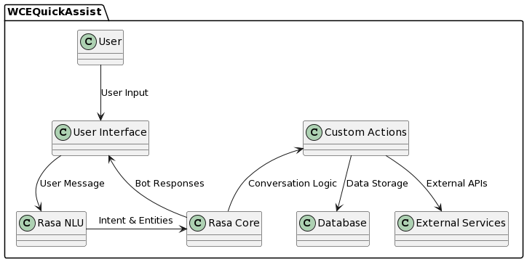

Figure 6.1

* This diagram illustrates the architecture of the "WCE QuickAssist Chatbot," showing the flow of data and interactions within the chatbot system. Components such as user input, natural language processing (NLU), dialogue management, custom actions, and data storage are represented, along with their connections, providing a visual overview of how the chatbot handles user interactions and external service integration.

**6.2 Activity Diagram:** 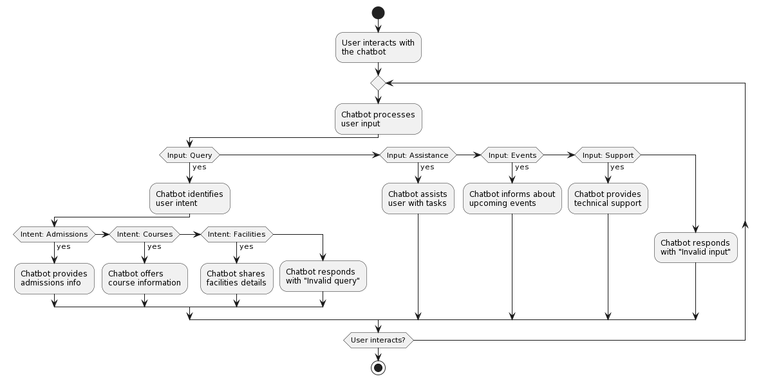

Figure 6.2

* 1. **Steps to implement an AI enabled chatbot:**

Steps involved in building a chatbot can be segregated into the following five distinct categories to ensure a structured and effective development process. These categories encompass essential phases that contribute to the creation of a functional and user-friendly chatbot:

* Reading text corpus.
* Pre-processing (Stop word removal, Lower case conversion, etc).
* Tokenization, Stemming and Lemmatization.
* Bag of Words.
* One hot encoding.

Certainly, let's delve into a more comprehensive understanding of the steps outlined above to gain a thorough insight into the intricacies of building a successful chatbot:

* + 1. **Reading text corpus:**

Corpus is nothing but block of text or information that we filled to this bot so that it becomes knowledgeable.

* + 1. **Pre-processing:**

It is application of text analytics and AI so we need do touching both the both cutting ages fields Machine Learning and Data Science. We need perform Stop words removal, lower case conversion and tokenization**.**

* + 1. **Tokenization, Stemming and Lemmatization:**

Tokenization is the process of breaking down a piece of text into individual units called tokens. In natural language processing (NLP), tokens are typically words, phrases, or symbols that have semantic meaning. Tokenization is a fundamental step in NLP and is used to prepare text data for various language processing tasks, such as text analysis, machine learning, and language modelling.

Stemming is a text normalization technique used in natural language processing to reduce words to their base or root form. The process involves removing suffixes or prefixes from words to obtain a common form, known as the stem. Stemming helps to group words with similar meanings together, which can be beneficial for tasks like text analysis and information retrieval. However, stemming might not always result in valid words, as it focuses solely on word reduction without considering linguistic rules. For example, the stemming of the words "running," "runner," and "ran" might result in the common stem "run."

Lemmatization is another text normalization technique that involves reducing words to their base or dictionary form, known as the lemma. Unlike stemming, lemmatization considers linguistic rules and context to ensure that the resulting lemma is a valid word. This technique produces more accurate and meaningful results compared to stemming.

* + 1. **Bag of Words**

The "Bag of Words" (BoW) is a basic and commonly used technique in natural language processing (NLP) for representing and analysing text data. It simplifies text by converting a document (such as a sentence or a paragraph) into a collection of individual words, disregarding grammar and word order. Each word in the document is treated as an independent unit, and its frequency of occurrence is noted.

* + 1. **One Hot Encoding**

It is a technique used in machine learning and data analysis to represent categorical data numerically. It's often applied when dealing with categorical variables that don't have any inherent numerical relationship or order. One-hot encoding is particularly useful for feeding categorical data into machine learning algorithms that require numerical input.

1. **UML DIagram**

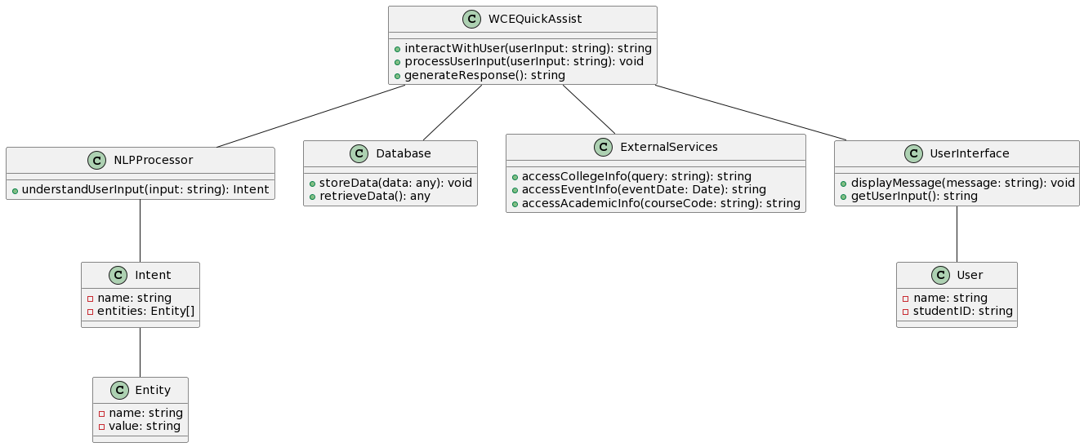

Figure 7.1

* **WCEQuickAssist:** Represents the WCE QuickAssist chatbot, responsible for interacting with users, processing input, and generating responses.
* **NLPProcessor:** Handles natural language processing to understand user input and determine intent.
* **Intent and Entity:** Intent represents user intention, while Entity represents specific information within user input.
* **Database:** Manages data storage and retrieval for the chatbot.
* **ExternalServices:** Provides access to external information related to the college.
* **User and UserInterface:** Represent the chatbot's interaction with users, including message display and input collection.

1. **OUTCOMES / Deliverables**

**8.1 Deliverables:**

* **Fully Functional Chatbot:** A functional AI-enabled chatbot named "WCE Helper" capable of engaging in natural language conversations.
* **User-Friendly Interface:** An intuitive and user-friendly chat interface for seamless interaction between users and the chatbot.
* **Integration with Existing Systems:** Successful integration of the chatbot with the college's existing systems and communication platforms.
* **Deployment on Platforms:** Deployment of the chatbot on the college's official website and potentially other communication platforms.

1. **TECH STACK**

**9.1 Programming languages:**

* Python: backend logic, natural language processing, and machine learning components.
* Html/CSS/JavaScript: user interface creation and chatbot integration into the college's website.

**9.2 Frameworks and libraries:**

* Rasa: natural language understanding (nlu) and dialogue management for user input comprehension.
* Nltk (natural language toolkit): text processing tasks like tokenization, stemming, lemmatization.
* TensorFlow or pytorch: implementation of machine learning models for nlp tasks.
* Flask or Django: backend server for user requests and responses.
* Frontend JavaScript framework (e.g., react, Vue, angular): user-friendly chat interface.

**9.3 Data storage:**

* Database (e.g., MySQL, PostgreSQL, mongo dB): user data, interaction history, and knowledge base storage.

**9.4 Version control and collaboration:**

* Git: codebase version control and team collaboration.

**9.5 Deployment and hosting:**

* Third-party apis: integration of external services like translation or speech recognition.

**9.6 Development tools:**

* Ide (e.g., visual studio code, PyCharm): coding and development.
* Command-line tools: dependency management, script execution.

1. **Project Potentials** 
   1. **Scope of project:**

* **Efficient Query Resolution:** Provide accurate and timely responses to user queries about the college.
* **24/7 Availability:** Enable users to seek help anytime, ensuring continuous support.
* **Navigation Assistance:** Guide users to relevant web pages for easy information retrieval.
* **Personalized Interactions:** Tailor responses based on user history for a more engaging experience.
* **Continuous Improvement:** Learn from interactions and feedback to enhance accuracy and relevance.
* **Seamless Human Handoff:** Transition users to human agents, when necessary, without disruption.
* **Data Collection:** Gather insights into user behaviour for informed decision-making.
* **Multichannel Integration:** Integrate with various communication platforms for consistent user experience.
  1. **Target Users:**
* **Students:** Access course information, schedules, grades, campus maps, and event details.
* **Faculty:** Retrieve class schedules, request facilities, and access teaching resources.
* **Staff:** Obtain information about office hours, department contacts, and administrative procedures.
* **Prospective Students:** Get information about admission requirements, application deadlines, and campus tours.
* **Visitors:** Get any details about college and academics.

1. **PRoject Plan**

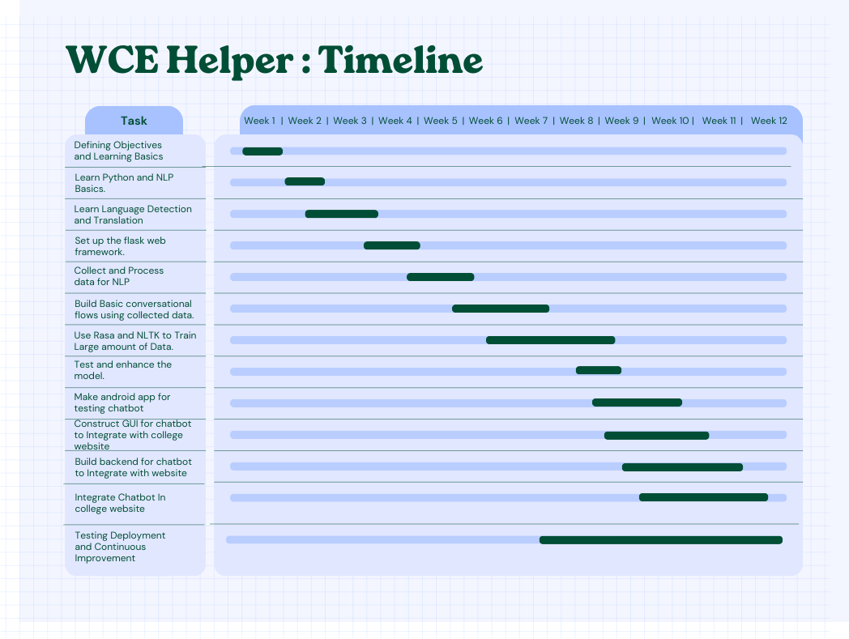

1. **References**
2. Boddula, Venkatesham. "design and implementation of a chatbot using rasa framework." in proceedings of the international conference on natural language processing and computational linguistics, 2022.
3. Haristiani, Nuria. "ai-powered chatbots for language learning: a literature review." in journal of educational technology, vol. 28, no. 2, pp. 123-140, 2021.
4. Dandekar, Niranjan, suyog ghode. "enhancing user experience through natural language processing: a case study of a chatbot implementation." in international journal of human-computer interaction, vol. 20, no. 3, pp. 245-260, 2019.